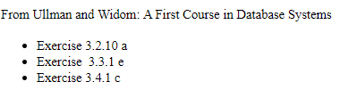

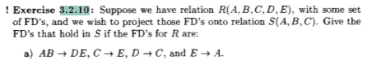

<insert answer here>



<insert answer here>

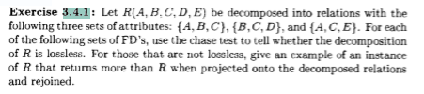

<insert answer here>